Q1. Query   
Select D.name, AVG(E.age) as Average_age from departments D LEFT JOIN employees E ON D.id = E.department_id

GROUP BY D.name  
  
Q2. Query

Select D.name, count(E.id) as No_of_employees from departments D LEFT JOIN employees E ON D.id = E.department_id

WHERE E.age > 40

GROUP BY D.name

ORDER BY No_of_employees DESC

LIMIT 1

Q3. solution

Select count(id) as Count_of_employees from employees where

DATEDIFF(DATE(NOW()), joining_date) <= 100

Q4 solution

with cte as(

SELECT id,

name,

age,

department_id,

CASE

WHEN department_id = 2 THEN DATE_SUB(CURDATE(), INTERVAL 1 DAY)

ELSE joining_date

END AS joining_date

FROM employees

)

Select * from cte

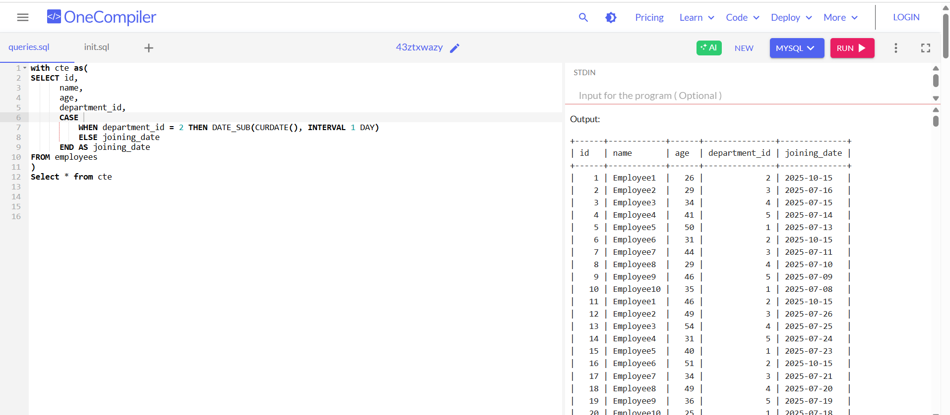  
**Comments: Data was not getting updated in the table , so created the cte**

Q5. solution

with cte as(

SELECT id,

name,

age,

department_id,

CASE

WHEN department_id = 2 THEN DATE_SUB(CURDATE(), INTERVAL 1 DAY)

ELSE joining_date

END AS joining_date

FROM employees

)

Select count(id) as Count_of_employees from cte where

DATEDIFF(DATE(NOW()), joining_date) <= 100

